Name_______________________________ Date_______________________

Images showing Ideology for Imperialism

Image 1: Lipton tea, capitalism, and imperialism

Capitalism = when businesses make profits by producing a supply of goods because ppl demand to buy it
Imperialism = when mother countries take over colonies and use them for their natural resources

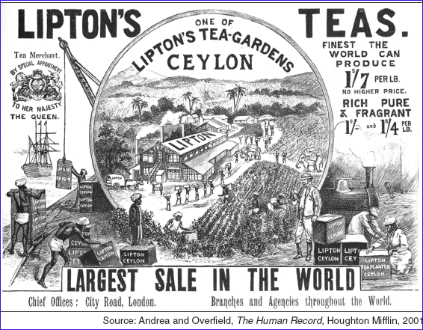

How does this advertisement show imperialism? ______________________________________________
____________________________________________________________________________________________________________________________________________________________________________
How does it show capitalism? _____________________________________________________________
______________________________________________________________________________________
______________________________________________________________________________________
Final Question: How does this show a capitalist motive for imperialism?

______________________________________________________________________________________
______________________________________________________________________________________
______________________________________________________________________________________
______________________________________________________________________________________
Image 2: Cartoon showing the “White Man’s Burden” (Burden = a difficult responsibility you have to do)
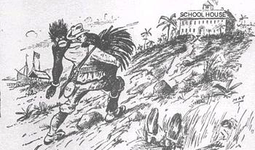
The White Man’s Burden is the idea that white people have a burden (responsibility) to help, teach, and civilize peoples of Africa and Asia. What assumptions does it make about those people in Africa and Asia?

______________________________________________________________________________________
______________________________________________________________________________________
______________________________________________________________________________________
______________________________________________________________________________________
Image 3: Cartoon of an African
Based on this cartoon, what is the “white man’s burden” for the Africans? How does he need to “help” them?
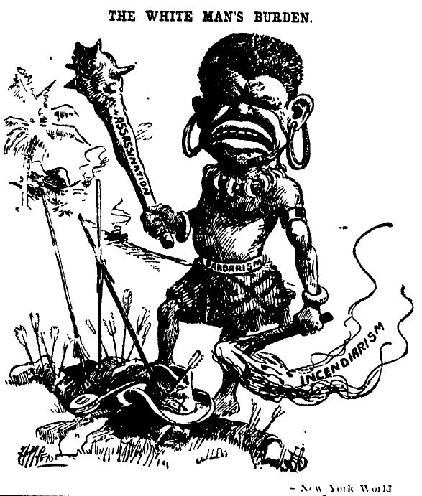
Image 4: Pear’s Soap Advertisement
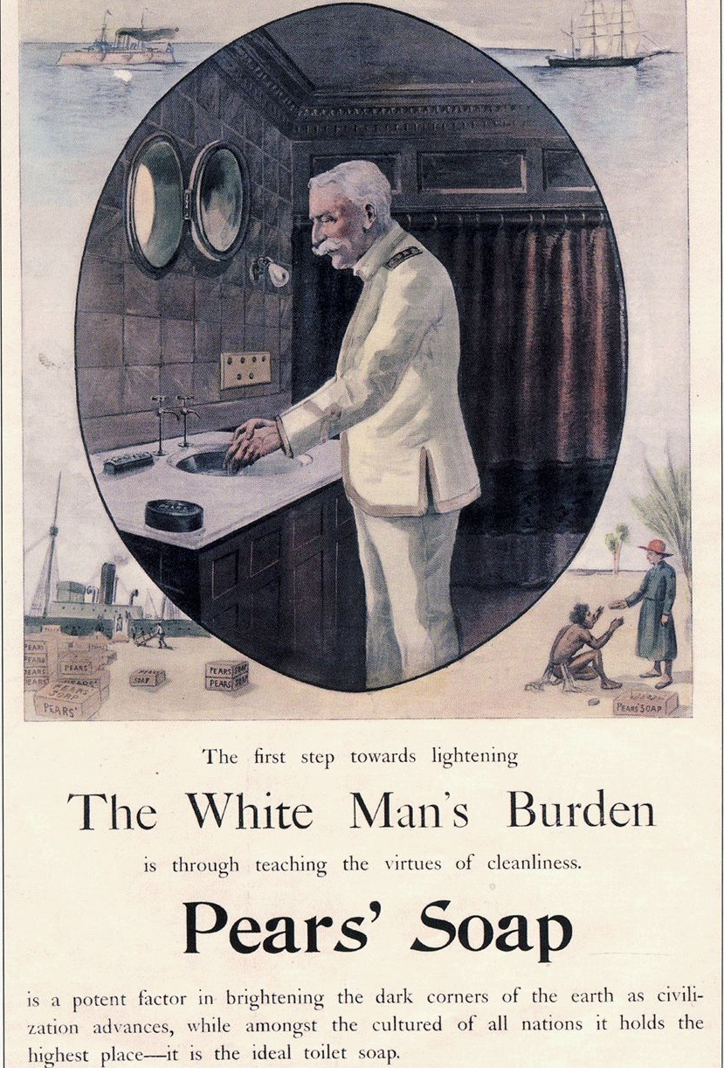
How is this advertisement showing the following ideas:
White Man’s Burden: __________________________________________________________________
______________________________________________________________________________________
______________________________________________________________________________________
______________________________________________________________________________________
Racism: ______________________________________________________________________________
______________________________________________________________________________________
______________________________________________________________________________________
Capitalism: ___________________________________________________________________________
______________________________________________________________________________________
______________________________________________________________________________________

reason

